Preparing to learn in a Zoom Classroom
Learning can occur anywhere, anytime, and anyplace. While this line sounds cliché, it has never rung more true than now. For a variety of reasons, instructors use synchronous, web-based platforms like Zoom to facilitate teaching and learning. This document will prepare you to participate in class meetings held in the online platform “Zoom.” It is strongly recommended that you read through this document and
1) prepare your computer,
2) prepare your learning space, and
3) prepare to present yourself!

1. Prepare your computer
Well in advance of your first meeting or class in Zoom, you should make sure your computer has been configured correctly to access a Zoom session. For your classes, it is strongly recommended that you use a laptop or desktop computer. For this class, we will also use a number of web-based tools that do not work on iPads or Smartphones, so please do not use them for this course.
- Chrome or Firefox Browser - These two browsers, the most current version of either, will work best for both Canvas and for Zoom. Prior to your first meeting, you can test your browser and download the free, small Zoom app via the following link: https://zoom.us/test
- You can test your internet connection speed by visiting Zoom's suggested third party bandwidth tester, Speedtest Click on the “Choose server” link to use a server in Charlotte.
- While you can participate in a Zoom meeting from the browser, you will experience greater stability if you download the Zoom client to your computer:
- More information can also be found at Zoom's Getting Started page.
If you have completed the Zoom test above, then you were presented with the opportunity to test both your audio and video. In addition to this test, the following recommendations will contribute to the overall quality of your audio and video.
- Consider a headset so that the microphone is closer to your mouth and the speakers are closer to your ears. This is of great importance for a language course. If you do not already own one, you do not have to spend a great deal of money to purchase a good quality headset. Take a look at headsets by Logitech. You should be able to find one within the $30 range.
- Many courses require that you participate via video. If your device does not have a built-in camera, consider purchasing one of the following:
  - Logitech HD ConferenceCam
  - Logitech HD Webcams
  - Microsoft HD Webcams
  - Freetalk HD Webcams

2. Prepare your learning space
Establish a space that you will use consistently as your “learning space.” While this may not be possible depending on your living arrangement, it is strongly recommended. Having a dedicated, reliable space for participating in Zoom sessions minimizes anxiety since you don’t have to constantly search for such a space. Knowing the space also minimizes any surprises since you already know the lighting, temperature, furniture, and location! You SHOULD NOT participate in class while you are at work at a full-time or part-time job. You would not be doing so in a face-to-face setting, and the integrity of the classroom is severely compromised if you attempt to do so via Zoom.

The best space is a space that works for you and provides you with the comfort, access, and conditions you need to be successful. Keep in mind, though, that you may have to sacrifice one of these if your first choice could be interrupted by someone talking or making noise in the room, some other technology or ambient noise nearby. A coffee shop is not a good location for a Zoom meeting!

Choose a space that you will not mind sharing on camera during the session. If you connect from your bedroom for example, bear in mind that others will see everything in the background. The same goes for any public space. For this and other reasons, coffee shops are not a good location to connect via Zoom. Also, attempt to avoid a window behind you since so much light will make you appear as a silhouette.

Organize materials and position your computer in advance of the session. Make sure you have everything you need in the same location as you would when attending a face-to-face class. Test the position of your computer to make sure it captures your face while minimizing the background. If a laptop, place it on a solid surface like a table or desk, avoiding sofa cushions or your lap since these would cause your camera image to move about during class, causing undue attention to your video!

3. Prepare to present yourself
While you may be wearing less casual clothing, occasionally sipping on coffee, and in a more relaxed environment than a university classroom, how you present yourself during a Zoom session is as important as how you would do so in a more formal classroom setting.

1. Do not disturb - First, make sure everyone in your immediate environment is aware that you will be “participating in a live class” in advance of the class start. Ask them to support your success by avoiding your learning space and waiting until the class is over to speak with you. Even if your microphone is muted, the visual distraction of you interacting with someone is a disruption.

2. Eating and drinking - Avoid both drinking and eating during your Zoom class. It is visually distracting. Remember that everyone can see you in the same way they can see you in a face-to-face setting.

3. Posture - Position yourself and your computer on a flat surface like a desk or table - something that allows you to be at eye-level with the video camera. It is essential for language learning that the instructor be able to see your face at all times. Do not use a laptop on your lap or on any other surface not at eye level. Please be seated or standing (if using a standing desk). Observe the same posture you would use in a face-to-face class. This means you are not lying down. Sitting on your bed, with the laptop will result in bad posture and will make it challenging to complete live activities.
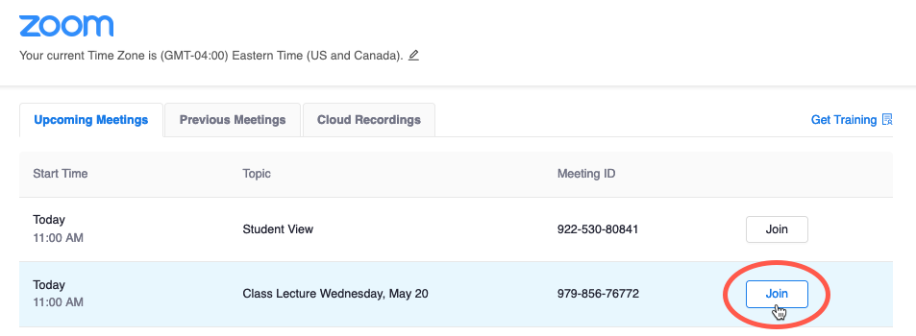
4. Arrival - Arrive 5-10 minutes prior to the start of every class so that you have plenty of time to address any unexpected technical issues. Also - arriving late is a disruption for your professor and does not respect the learning environment that you share with other learners.

To access your Zoom classroom,
- Click on the “Zoom” link from your Canvas course navigation menu.
- Click “Join” for the meeting you want to attend

5. Sign in - Sign in using your first and last name. Do not use a nickname or pseudonym since your instructor relies on seeing your name for both attendance purposes and classroom management. You may also be prompted to provide a passcode which will be provided to you via email in advance of the session.

6. Mute yourself - Once you have entered the Zoom Room, make sure your microphone is on mute unless your instructor requests otherwise. This helps eliminate background noise. Use your headset if you have one. If your connectivity to the Internet is not very strong, you may have to turn off your webcam, but do not do so unnecessarily. An easy way to unmute yourself is to hold down the space bar on your keyboard while you talk. Releasing the spacebar reverts to the muted status.

7. Zoom views - When your instructor is not sharing his/her screen, you can change how you see everyone’s video by hovering your cursor at the top right of the Zoom Meeting Window to access icons representing the different views:
When in Speaker View, click this option to see all videos.

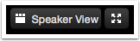
When clicked, this view focuses on the person who is speaking, highlighting that person’s video.

If you want to make the Zoom meeting fill your entire screen, click this option.

8. The Zoom Menu - You can access the Zoom menu by hovering your cursor over the bottom of the Zoom Meeting Window.
- Mute: Silences and unsilences your microphone.
- Share Screen: Allows you to share a variety of windows and applications. You can share views of your desktop and specific windows currently open on your computer, write on a digital whiteboard, and even share a screen directly from your iPhone or iPad if your instructor gives you access.
These features (and more) are outlined thoroughly here.
- Chat: You can send messages to everyone, just the professor/meeting host, or a specific person.
- Record - It is likely this has been disabled, so don’t worry about it. Your instructor might record the session.
- Leave Meeting: Click this when you're ready to leave.
Zoom with Zeal
The following tips will help you look your best on camera and avoid unnecessary attention or potential embarrassment: (Adapted from Humboldt State University)
- Broadcasting clear video is a lot like taking a good selfie -- it's all about contrast. Light your face more brightly than the background to make it easier to see you.
- Hold your head high in the picture frame. It conveys confidence.
- Keep your clothing PG and professional.
- Be yourself. Move physically and make facial expressions.
- Microphones pick up all ambient noise, so keep your mic muted until it's your time to speak.
- Remember that when on-camera, other activities such as eating, drinking, shuffling papers, etc are extremely distracting (and sometimes unflattering).
- If you can't use video, upload a nice profile image of your face to your Zoom Account. Give your classmates something to look at while you speak
Last updated: 2 January 2022

